Amateur Football Combination
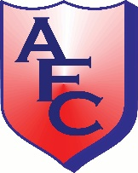
National Respect Gold Award League 2012
Team * |  | Opponents *
Shirt Colour/s * |  | Match Date *
Competition/Division * |  | Referee

Shirt No * | Players First Name *  (PLEASE PRINT) | Players Surname *  (PLEASE PRINT) | Mobile Number
 |  |  | 07
 |  |  | 07
 |  |  | 07
 |  |  | 07
 |  |  | 07
 |  |  | 07
 |  |  | 07
 |  |  | 07
 |  |  | 07
 |  |  | 07
 |  |  | 07
 |  |  | 07
 |  |  | 07
 |  |  | 07
 |  |  | 07
Manager |  |  | 07

