**COMING UP NEXT….**

FA Inter League Cup

2nd Round Away to Bedfordshire County League

25 November 2017,

Kick off 3pm

**WE NEED YOUR SUPPORT**

# The Argonaut Trophy &

# The Steve Langley Cup

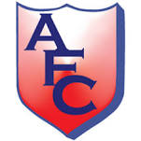

# **Amateur Football Combination**

V

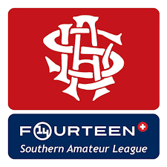

# **Southern Amateur League**

Uxbridge Football Club

15 November 2017

Kick Off 7:30 pm

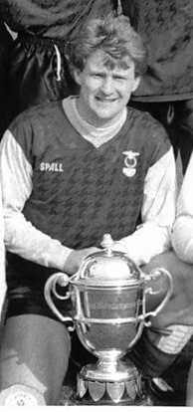

Let us remember one of the main reasons we are all gathered here tonight which is to remember and honour Steve Langley, the former SAL, AFA and Crouch End Vampires captain who tragically lost his battle with lung cancer aged just 42 in 2003.

The AFC haven’t won this fixture since defeating our rivals 3 -2 in 2009-10 and hope to put an end to that trend tonight.

In memory of Steve and also the recent passing of a number of AFA, AFC & SAL stalwarts please join us for a minutes silence prior to kick off.

**John Maskell**

Chairman of the AFC &

President of the of Amateur Football Alliance

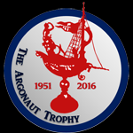

## Steve Langley

**Amateur Football Combination**

Red Shirts, Red Shorts, Red Socks

From

Henry Warne (GK) - Dorkinians   
Aidan Chapman (Captain) - Old Meadonians   
Charles Gerson  - Old Hamptonians   
Charlie Cain  - Old Meadonians  
Chris Heritage  - Old Hamptonians   
Ellis McLennon  - Old Suttonians  
George Proctor  - Old Suttonians   
Manny Soderu  - Clapham Old Xaverians  
Phil Dunnett  - Old Minchendianians   
Ryan Bright  - Old Meadonians  
Sarf Pivano - UCL Academicals  
Shane Banbridge  - Old Minchendianians  
Stuart Holt - Old Meadonians   
Timi Dorgu  - Old Parmiterians  
Zach Francis  - Old Suttonians

Manager - David Cross

Coaches - Chris Parlett & Aaron De Silva

**Southern Amateur League**

Black & Blue Shirts, Black Shorts, Black Socks

From

Ben Lancaster (Gk) - Nottsborough

James Cranston - Nottsborough

Sean Gavin - Nottsborough

Dan Barber - Nottsborough

Richard Parker - Nottsborough

James Cree - Polytechnic

Ollie Mongul - Polytechnic

Graham Harrisom - Polytechnic

Lee Raji - Polytechnic

Paul Bogle-Fearon - Alleyn Old Boys

Jordan Greaves - Alleyn Old Boys

Rhys Watling - Bank of England

Scott Ensom - Actonians Assoc

Phil Obi - Ibis Eagles

Manager - Bob Leeds

Coach - Pat Folan

**Match Officials**

Referee - Deryl David

Assistant Referees – Derrick Coe & Geoff Blackmore

4th Official- Liam Giles

Our thanks to Bob Coates for supplying the Match Officials

**!**

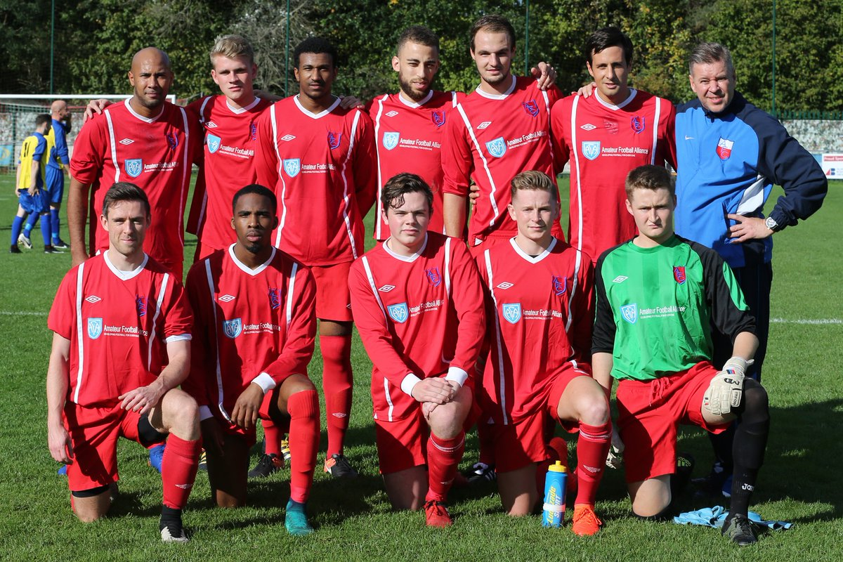

On behalf of the Amateur Football Combination I would like to take this opportunity to welcome the Players, Officials and supporters of our old friends from the Southern Amateur League.

We kick off campaign in the Argonaut Trophy on the back of an encouraging start in the FA Inter League Cup against Anglian Combination with a good 5 – 0 in the first round.

Despite the good start, I would be the first to acknowledge we were fortunate in that game, Our man of the match was Henry Warne making his debut in goal, which gives plenty to think about going into this game and indeed for the next round against Bedford, who coincidentally beat the SAL 6-4 in the previous round.

Since that game, SAL Manager and AFA Manager saw it fit to award call ups to the County side for Henry, Aidan Chapman, Charlie Cain, Timi Dorgu, Chris Heritage and Charles Gerson.

Enjoy the game and let’s hope both teams put on a display worthy of the competition

David Cross

## The Teams

## Off The Cross Bar!